Manual

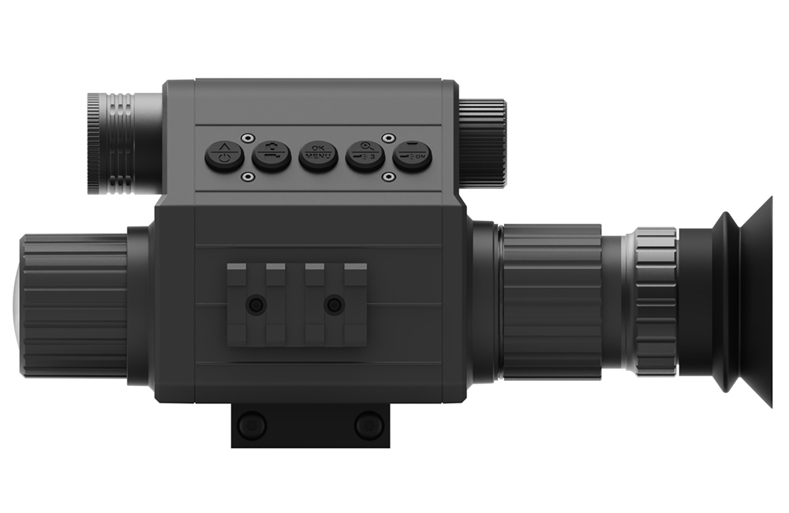

Product Overview

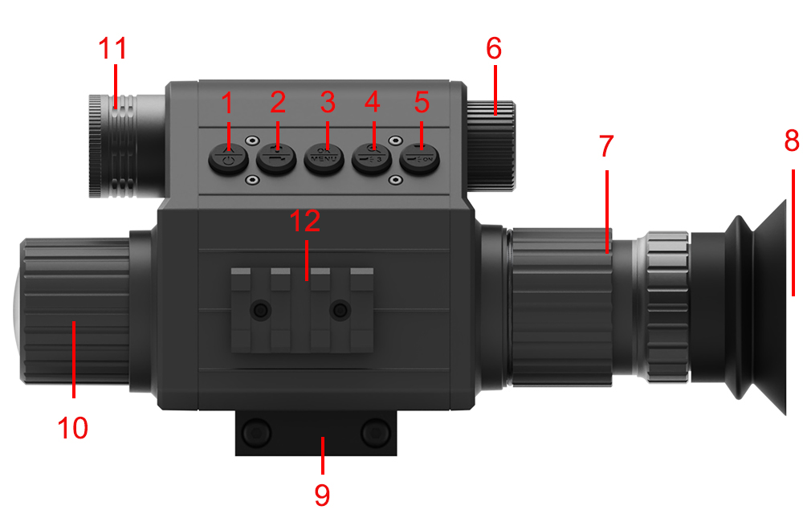

14
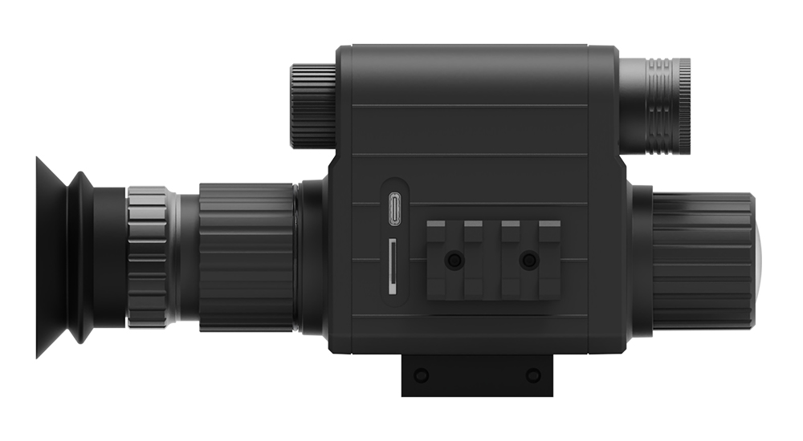
13

Product overview
Long press | Short press
1.Power on/off | 1.Up
2.Record video | 2.Take photo
3.Turn on/off MENU | 3.OK
4.IR up/down (3 levels) | 4.Zooming from 1x - 5x
5.Turn on/off IR | 5.Down
6.Battery compartment cap | 7.Eyepiece dioptric adjustment ring
8.Display/eyepiece | 9.Rail mount
10.Objective lens focusing wheel | 11.Stretchable IR light
12.Rail mount | 13.Micro SD card slot
14.Type-C USB port

M5 PARAMETER
Display | 1.2-inch circular screen, full viewing angle display
Camera Sensor | 200W pixel 1080P
Lens | 16mm/25mm/35mm/50mm lens optional
IR | Laser IR 850nm/940nm Optional
Cross | Adjustable
Digital Zoom | 5X
Battery | 1PC 18650
Working Time | 2600mAh 1.5hours, if IR turn off, 5-6hours
Work Voltage | 3.7V
Video Resolution | 1920*1080
Output Type | AVI
Storage Type | TF Card Max 128GB
Functions | Photo&Video Record
Anti-shock | Passed 2M drop test
Special Function | New Update AI Zoom

1.Install Batteries
Unscrew the battery cover and use a 18650 lithium-ion rechargeable battery with a rated voltage of 3.7V, and install it with the positive electrode facing inward to ensure that the battery cover is tightened.

2.Inserting Memory Card
Please prepare a Class 10 Micro card(up to 128GB) in advance.
Insert the Micro SD card into the slot. Make sure the direction is right. Never insert the card forcibly.

3. The eyepiece adjustment
Eyepiece focusing or dioptric adjustment is designed to help users with different visions see a clear view. Just one time tuning is needed for an eye of one certain user.
Please turn the eyepiece dioptric adjustment ring till characters appeared in the screen become sharp.
(Please note the image obtained now may be breezing before doing objective lens adjustments.)

- The objective lens focusing
Aim at your target, turn lens focusing wheel until you've achieved an stable and clear image.

Basic operation
Turn On And Turn Off
Long press the POWER button(1) for 3 seconds to turn on the device. Long press the POWER button(1) to turn off the device. Watch the eyepiece/display screen (8) and adjust the lens focusing wheel (8) according to the actual distance to focus until the screen is clear. If the light is insufficient or used at the night, turn on the IR by long pressing the IR button(5). Increase the brightness by pressing the IR up button (4) repeatedly. It has 3 levels of brightness, The fill light is also stretchable so that it can be pulled and pushed to fill light.

Take picture/Record Video
Turn on the device, short press the Video/photo button(2) to take a photo. Long press the Video/photo button(2) for 2 seconds to take video.

Zooming
Keep pressing the Zoom button(4) to zoom in or zoom out the image. Zooming from 1x - 5x

IR light brightness control
In black and white mode, repeatedly press the IR light brilliance control button (4) to adjust IR light brilliance among range of 3 gears(set IR1-3). The fill light is also stretchable so that it can be pulled and pushed to fill light.

Menu operation
Press Menu button to call out menu. Press Up/Down button to select each sub-menu. Press OK to enter the settings.

Menu | Function
Contrast Ratio | night&day mode effect setting
Language | English/Español/português/Polski/Français/Pусский/Italiano/Deutsch/عربي/Japanese
Crosshair | on/off
Crosshair adjustment | crosshair can move up, down, left and right, when the adjustment is completed, press the OK key to confirm
Video Prompt | on/off
Mic | on/off
Playback Mode | playback videos or photos
Date | on/off
Time | set up- time
Screen Protection | off/3/5/10
How to install

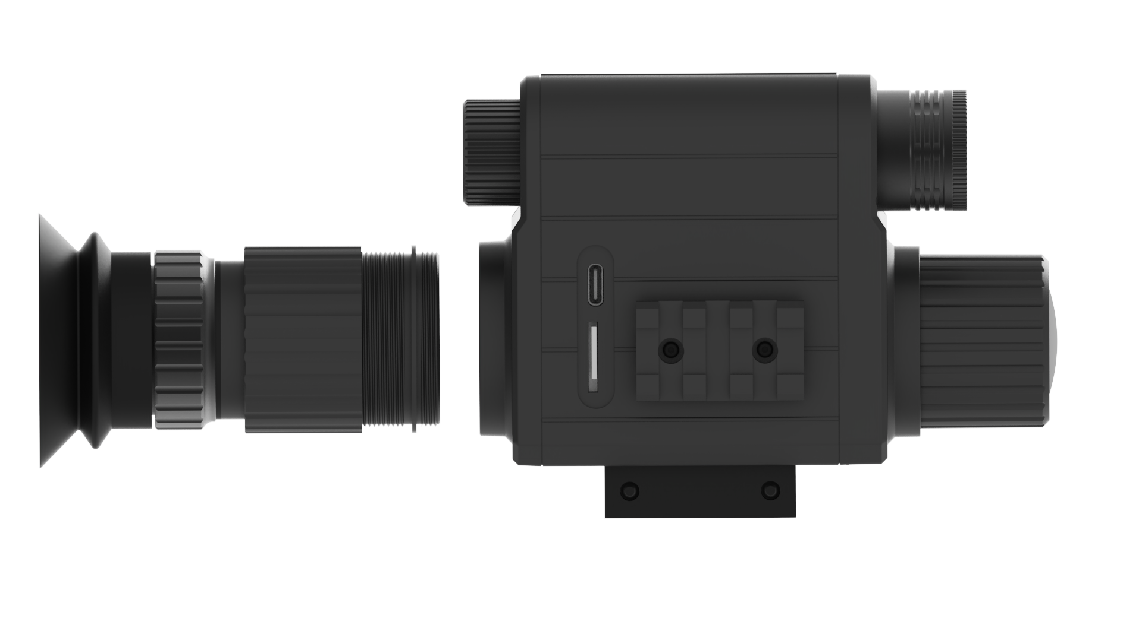
Install the eyepiece into the machine
Type-C USB you can charge the battery or use the mobile power
Micro SD card slot

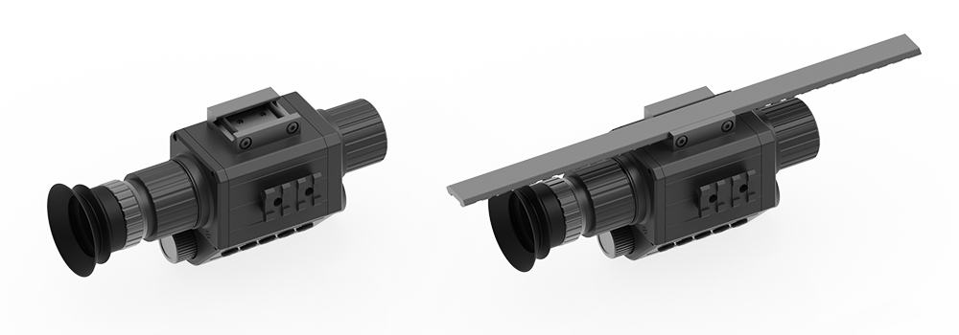
Install the machine
on the railway
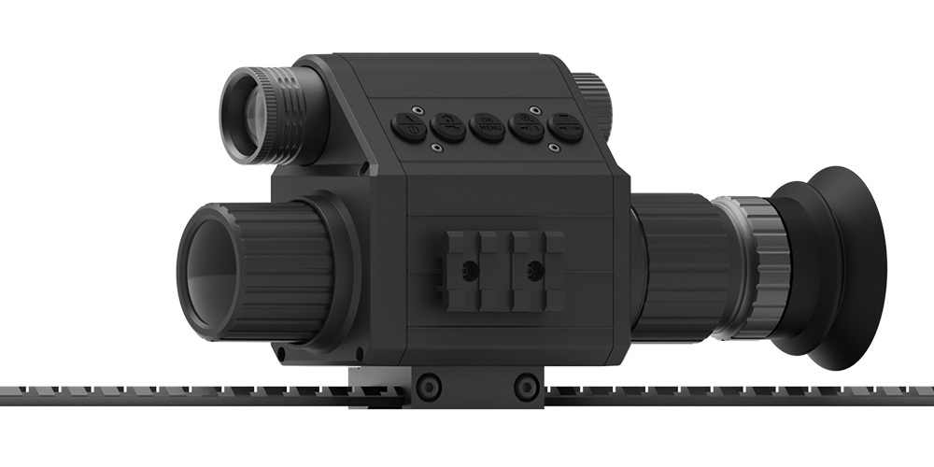

Adjust the focus to get
the right IR light distance

Note the “+” and ”-”

Adjust the lens to get clear
Through rotation adjustment,
to get a clear image


How to choose the model

Model and configuration guidance
Model | Lens | IR | Model | Lens | IR
M5-16-850 | 16mm | 850nm  Laser IR | M5-16-940 | 16mm | 940nm  Laser IR
M5-25-850 | 25mm | 850nm  Laser IR | M5-25-940 | 25mm | 940nm  Laser IR
M5-35-850 | 35mm | 850nm  Laser IR | M5-35-940 | 35mm | 940nm  Laser IR
M5-50-850 | 50mm | 850nm  Laser IR | M5-50-940 | 50mm | 940nm  Laser IR

How to choose the lens

Lens | Optical zoom | Distance
16mm | X1 | 0-50m
25mm | X1.5 | 0-80m
35mm | X2 | 0-120m
50mm | X4 | 0-200m

How to choose the IR

What is the difference of the IR
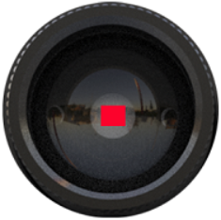 | 850nm laser IR  more strong more faraway  200-400m
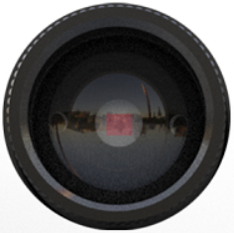 | 940nm laser IR  more secret  200-300m

How to replace the lens
Note:you can order 4 kind of lens and replace it depend on you, we can send the video how to replace the lens!
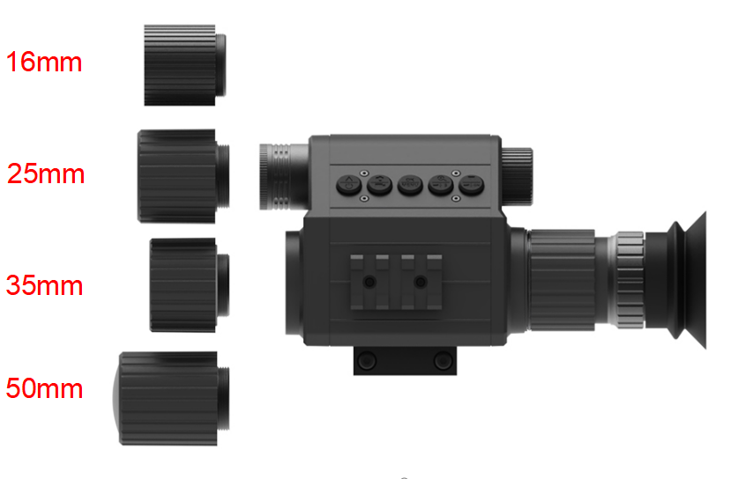
Important Notes
1. Do not look directly at the IR at a close distance, otherwise it will cause damage to the eyes!
2. When the infrared light of this product is turned on, it will focus a lot of energy. It is strictly forbidden to aim at flammable objects at close range, otherwise it may cause a fire. Please turn off the IR after you do not use it.
3. Different distance need different lens, when you meet some problem, please contact the seller at first time, all the problem,we will solve for you in time!
4. We will upload many videos to help you better use this device! Please contact us!

