**NK007 Manual**

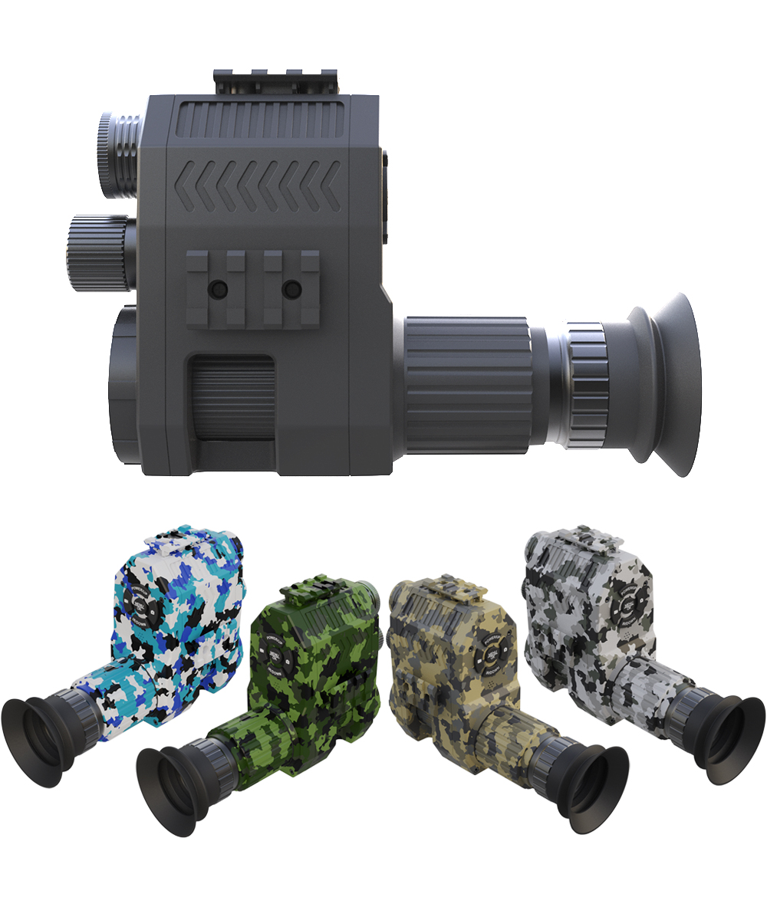

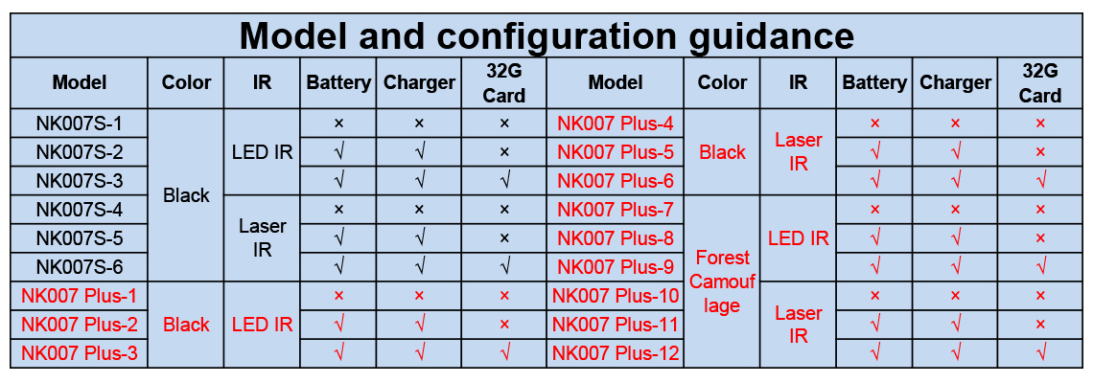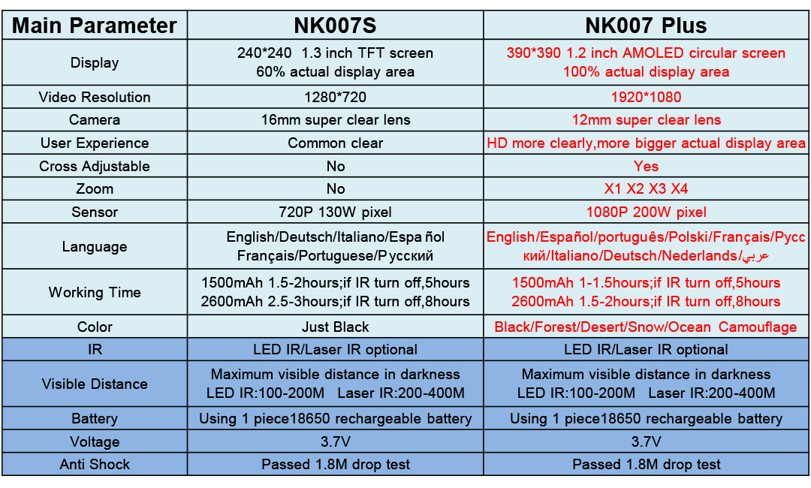

**INSTALLATION**

1. Put 1 piece 18650 battery(not included) in battery compartment(as photo showed ⑦).
2. Put the ② in the rear of the eyepiece of the telescope①.
3. Fix the ③ in the rear of the eyepiece of the telescope①.
4. Tighten the ④and ②.
5. Tighten the ⑥and ⑤.

**Adjust the focus to get the right IR light distance**

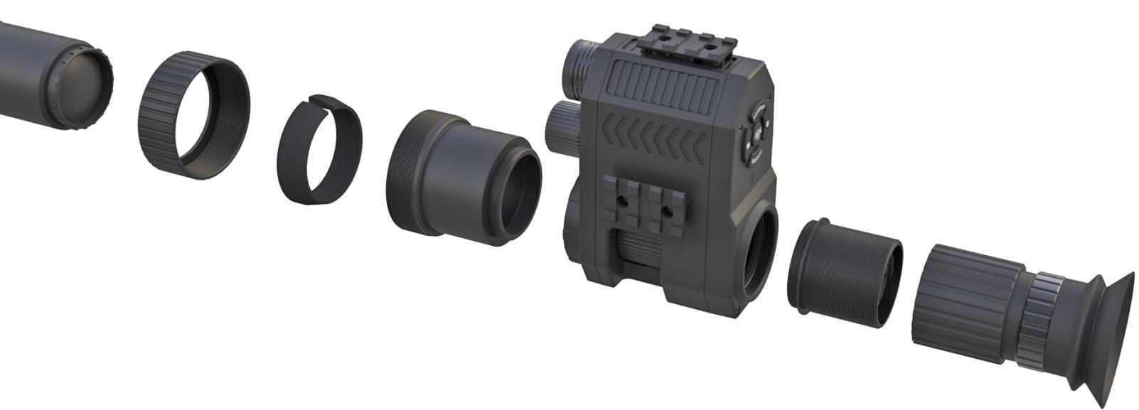**BUTTON DISPLAY**

**Battery compartment**

⑦

⑥

⑤

④

③

②

①

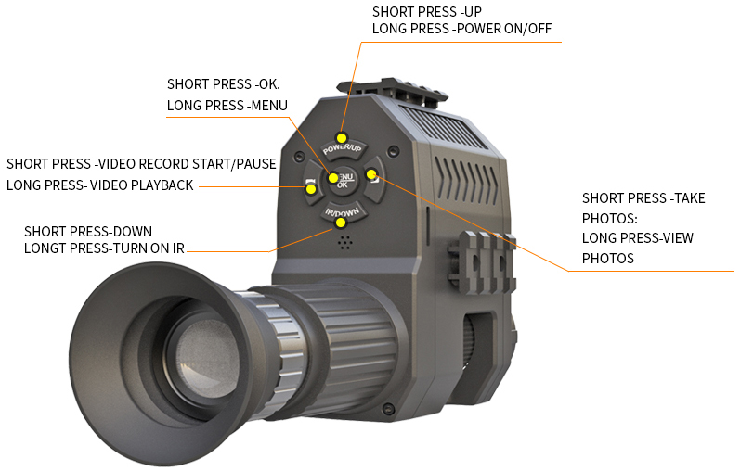

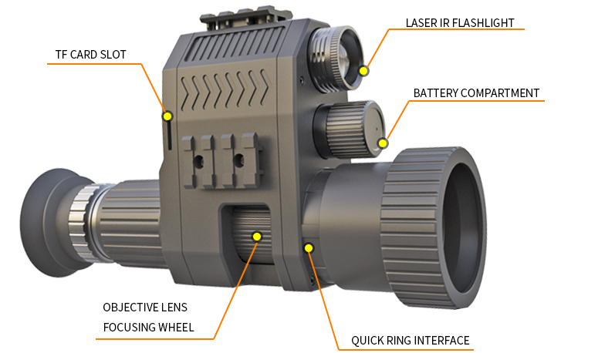

**MENU**

**NK007S Menu**

Video Record/Take Photo

Loop Record

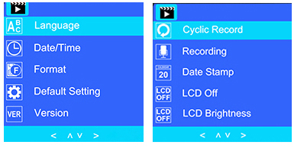

720P HD Resolution

Recording Time

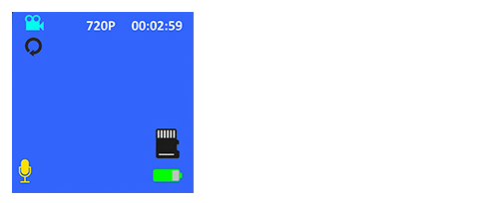

**We provide 7 language options, included**

**English/Deutsch/Italiano/Español**

**Français/Portuguese/Pусский**

Battery Capacity

Micro SD Card(Not Included)

Voice Record

**NK007 Plus Menu**

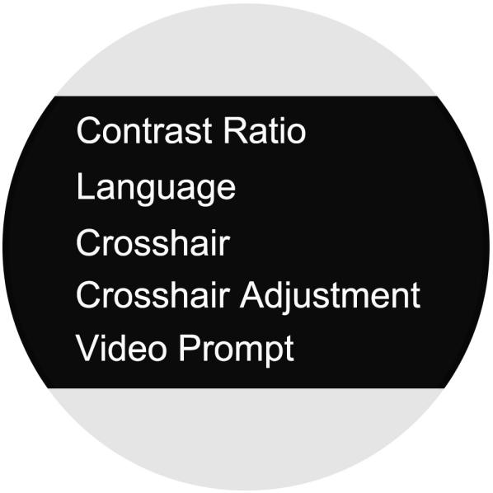

**Contrast Ratio** :night&day mode effect setting

**Language** :English/Español/português/Polski/Français/Pусский/Italiano/

Deutsch/Nederlands/عربي

**Crosshair** :On/Off

**Crosshair Adjustment** :Crosshair can move up, down, left and right,when the adjustment is completed, press the OK key to confirm

**Video Prompt** :Off/ON

**DIOPTER ADJUSTMENT LENS**

**For presbyopia&myopia,Through rotation diopter lens adjustment, you can get a clear image .**

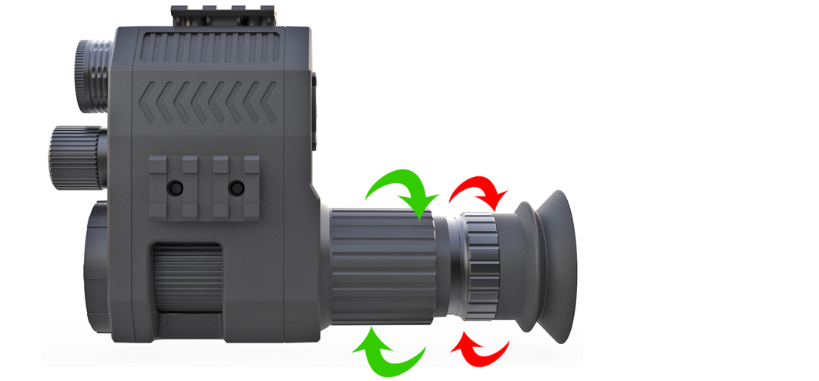

For fine-tune ,

The adjustment range is 10 mm

High presbyopia adjustment ,

The adjustment range is 35 mm

①

**①**

**②**

②

**HOW TO INSTALL THE DIOPTER LENS**

**Step1**

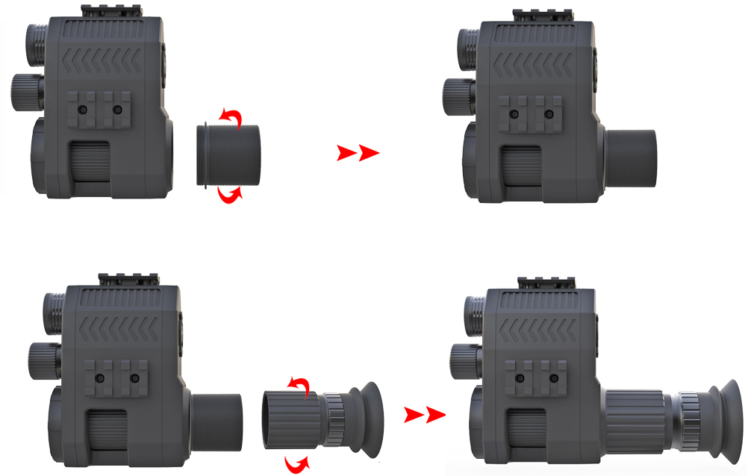

**Install the adapter ring**

**to the screen interface.**

**Install the presbyopic lens**

**to the adapter ring**

**Step2**